*Our Water, Our Future*

WATER QUALITY REPORT

Contoso Public Utilities

Spacing

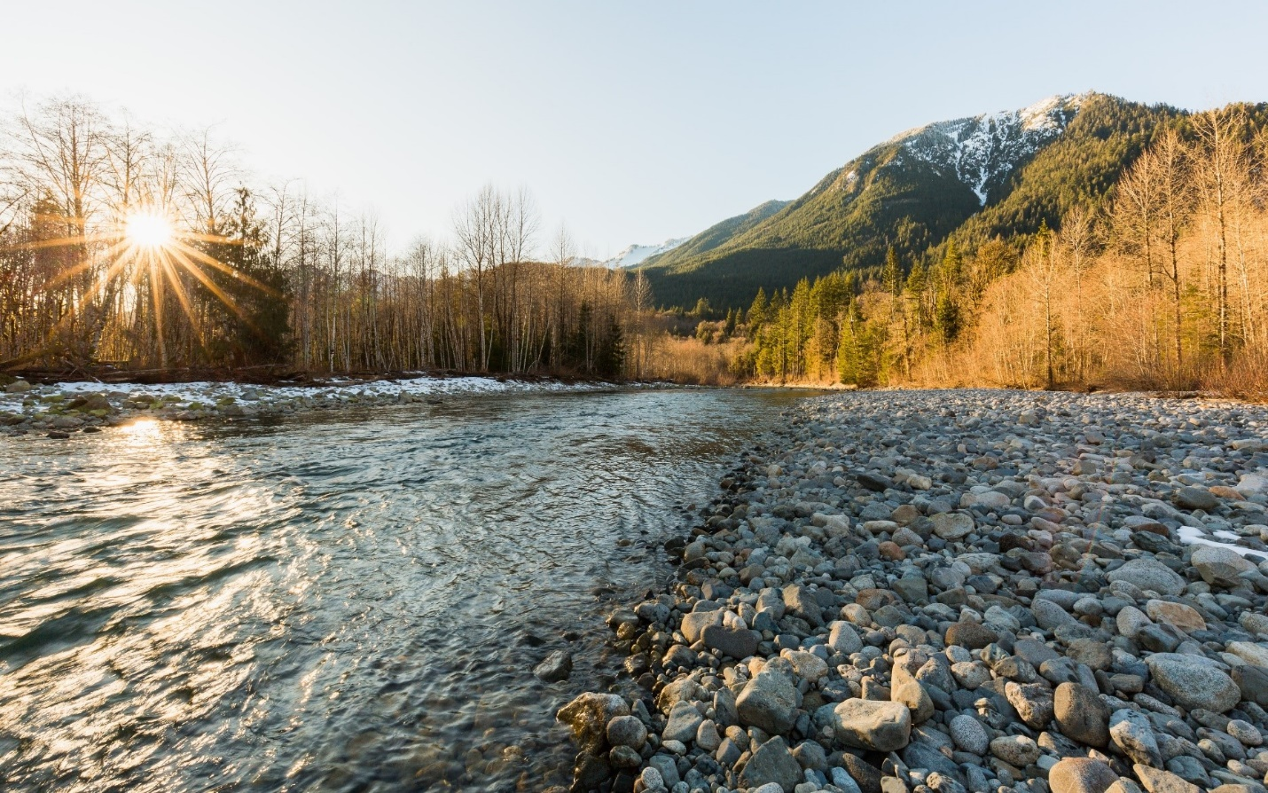

# A Letter from the General Manager/CEO

Dear Customer,

Water is essential to life, and every community should be able to rely on the safety, high quality, and affordability of the water they use every day. Contoso is fortunate to have some of the best water in the nation, sourced from protected watersheds high in the Cascade Mountains, and it is Contoso Public Utilities’ (CPU) job to take care of it.

In addition to important facts about our water quality, this year’s Drinking Water Quality Report contains information that demonstrates CPU’s commitment to stewarding this essential resource and ensuring that Contoso residents can depend on water quality and reliability now and into the future. This report also highlights ways CPU partners with customers and communities. As we work to become a more community-centered utility, we recognize the vital role that our community plays in protecting our water resources and ensuring we deliver our services in equitable and inclusive ways. Our work makes a difference in people's lives, and we look forward to doing even more to address challenges and community values through collaboration and partnership.

I hope the information in this report helps you connect to this valuable resource that we all share.

Sincerely,

Mami Hara

General Manager/CEO

*Contoso Public Utilities*

**Safety First**

Contoso’s drinking water surpasses all federal and state drinking water standards.

CPU tests and treats your water every day. The expert testing and engineering staff at our water quality laboratory is committed to keeping your water clean. We test samples from the region between 10 and 100 times per day. Key points within the water system are monitored 24/7. We are engaging with BPO to get data on supplier reliability for this component. Customers will also be able to organize their photos for editing and sharing via a new mobile app we have in development. Upon launching, our goal is to have a MAU of 100,000 within 6 months.

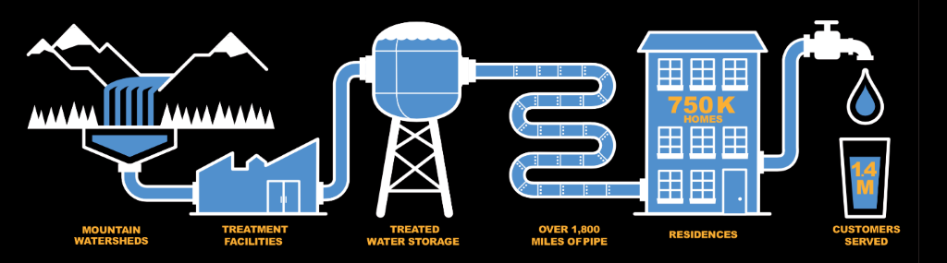

There are more than 90 water sampling stations throughout Contoso and surrounding areas that CPU uses to test the quality of your drinking water every day.

# 2017 Water Quality Results

Water quality monitoring data can be difficult to interpret. To make all the information fit in one table, we used many acronyms that are defined below the table. In Contoso, if you live south of Green Lake, your water probably comes from the Cedar. Areas north of Green Lake usually receive Tolt water. Each source can provide water to other areas in Contoso if needed.

|  |  |  |  |  |  |  |
| --- | --- | --- | --- | --- | --- | --- |
| **EPA’S ALLOWABLE LIMITS** | | | **LEVELS IN TOLT WATER** | | |  |
| RAW WATER | | |  | | |  |
| Total Organic Carbon | ppm | NA | TT | 1.4 | 1.1 to 1.3 |
|  |  |  |  |  |  |
| FINISHED WATER |  |  |  |  |  |  |
| Turbidity | NTU | NA | TT |  | 0.01 to 0.20 |  |
| Arsenic | ppb | 0 | 10 | 0.04 | 0.3 to 0.5 |  |
| Barium | ppb | 2000 | 2000 | 0.4 | 1.1 to 1.7 |  |
| Bromate | ppb | 0 | 10 | 1.4 | ND to 2 |  |
| Chromium | ppb | 100 | 199 | 0.25 | ND to 0.24 |  |
| Fluoride | ppm | 4 | 4 | 0.2 | 0.6 to 0.8 |  |

# Definitions

**MCLG:** Maximum Contaminant Level Goal - The level of a contaminant in drinking water below which there is no known or expected risk to health. MCLGs allow for a margin of safety. **MCL:** Maximum Contaminant Level - The highest level of a contaminant that is allowed in drinking water. MCLs are set as close to the MCLGs as feasible using the best available treatment technology.

**MRDL:** Maximum Residual Disinfectant Level - The highest level of a disinfectant allowed in drinking water. There is convincing evidence that addition of a disinfectant is necessary for control of microbial contaminants.

**MRDLG:** Maximum Residual Disinfectant Level Goal - The level of a drinking water disinfectant below which there is no known or expected risk to health. MRDLGs do not reflect the benefits of the use of disinfectants to control microbial contaminants.

**TT:** Treatment Technique - A required process intended to reduce the level of a contaminant in drinking water.

**NTU:** Nephelometric Turbidity Unit - Turbidity is a measure of how clear the water looks. The turbidity MCL that applied to the Cedar supply in 2017 was 5 NTU, and for the Tolt it was 0.3 NTU for at least 95% of the samples in a month. 100% of the Tolt samples for 2017 were below 0.3 NTU.

**NA:** Not Applicable ND: Not Detected

ppm: 1 part per million = 1 mg/L = 1 milligram per liter

ppb: 1 part per billion = 1 ug/L = 1 microgram per liter

1 ppm =1000 ppb

**CONSERVATION-FOCUSED**

Water conservation is important for us, our environment and future generations.

* Water conservation helps protect an important, shared natural resource. It keeps more water in our rivers for salmon, wildlife, and other environmental needs.
* Water conservation stretches our valuable water supply to meet the needs of our growing region, ensuring we’ll have enough water for future generations.
* Using water efficiently can help customers keep water and sewer bills as low as possible.
* These results show that it is very important that homeowners, business owners and others be aware of their type of plumbing, and how the plumbing affects their drinking water quality.
* Our research and forecasting will help drive these deliverables, milestones and plans.

To encourage efficient water use, the Saving Water Partnership (SWP)–CPU and 18 water utility partners–set a six-year conservation goal: reduce per capita use from current levels so that the SWP’s total average annual retail water use is less than 105 million gallons per day (mgd) from 2013 through 2018 despite forecasted population growth.

In 2017, our customers met this goal, using 96.6 mgd. These results show that it is very important that homeowners, business owners and others be aware of their type of plumbing, and how the plumbing affects their drinking water quality. Our research and forecasting will help drive these deliverables, milestones and plans.

Visit the Saving Water Partnership for more information on rebates, conservation tips, videos on fixing leaks and natural yard care, and more. Go to **savingwater.org.**

# 5 Reasons Contoso’s Water is Better Than Bottled

We take pride in the fact that our water is better for you than bottled. Here are some reasons why:

Tastes Great

Protected and Safe

Affordable

Fresh and Pristine

Better for the Environment

# Lead and Copper Monitoring Results

Although there is no detectable lead in our source water, tests show there are sometimes elevated levels of lead and copper in some samples, primarily because of corrosion of household plumbing systems. These results show that it is very important that homeowners, business owners and others be aware of their type of plumbing, and how the plumbing affects their drinking water quality. Our research and forecasting will help drive these deliverables, milestones and plans.

Where you live, when your plumbing was installed and what type of plumbing you have, all play a part in determining your potential exposure level. CPU treats the water to minimize the tendency for lead to enter the water, and results show that we have been very successful at this. In ContosoState, lead in drinking water comes primarily from materials and components used in household plumbing. The more time water has been sitting in pipes, the more dissolved metals, such as lead, it may contain. Elevated levels of lead can cause serious health problems, especially in pregnant women and young children.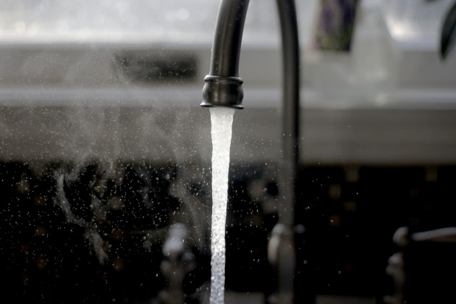

To help reduce potential exposure to lead and copper: for any drinking water tap that has not been used for six hours or more, flush water through the tap until the water is noticeably colder before using for drinking or cooking. You can use the flushed water for watering plants, washing dishes, or general cleaning. Only use water from the cold-water tap for drinking, cooking, and especially for making baby formula. Hot water is likely to contain higher levels of lead. If you are concerned about lead in your water, you may wish to have your water tested. Information on lead in drinking water is available from EPA’s Safe Drinking Water Hotline at **1-800-426-4791** or online at **epa.gov/safewater/lead**.

Finally, remember that drinking water is only a minor contributor to overall exposure to lead. Other sources, including paint, soil, and food, also contribute. To remain safe, do not consume items from these other sources.

For more information about your water, contact:

##### Contoso Public Utilities

contoso.gov/util/waterqualityrep